

**Mathematics Specialist**

**Test 6 2016**

**Statistical Inference**

**NAME: _______________________________________________ TEACHER: MLA**

**45 marks**

**45 minutes**

**One unfolded A4 page of notes, SCSA formulae booklet and ClassPad calculator permitted**

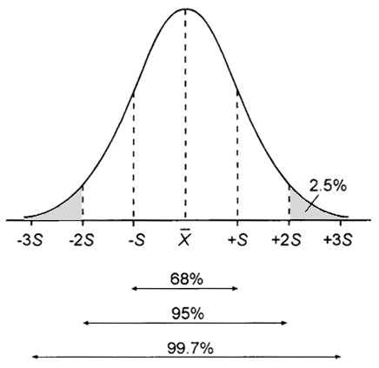

**Question 1 [3, 3 & 3 = 9 marks]**

(a) What is the mean and standard deviation of a sampling distribution for a binomial distribution with $n=36 and p=0.7$ for samples of size 40?

(b) The mean time between delivery destinations for a truck driver is 27 minutes, with a standard deviation of 7 minutes.

(i) What is the probability that the next 5 stops will take more than two hours?

(ii) Comment on the validity of your answer.

(c) A company is asked to produce stainless steel rods with lengths accurate to within $0.005mm$ with a 95% confidence level. If $σ=0.008mm$, how many stainless steel rods are necessary to satisfy this request?

**Question 2 [4 & 1 = 5 marks]**

A sample of kookaburras from the Central West region of Western Australia were captured and carefully weighed, yielding the following results (in grams):

|  |  |  |  |
| --- | --- | --- | --- |
| 460 | 205 | 297 | 494 |
| 238 | 465 | 299 | 260 |
| 477 | 344 | 240 | 211 |
| 419 | 470 | 248 | 271 |
| 357 | 492 | 362 | 201 |

(a) Assuming the sample to be random with a distribution close to normal, determine a 99% confidence interval for the mean weight of kookaburras in Western Australia.

(b) Is the confidence level found above valid for the population of kookaburras in Western Australia? Explain.

**Question 3 [3 & 3 = 6 marks]**

The wing-span of a species of bird is known to be normally distributed with length 45cm and variance 25cm. It is suspected that a random sample of 30 birds with mean wing-span of 47cm belongs to the same species.

(a) Determine if the mean length of this sample is significantly different at the 5% level

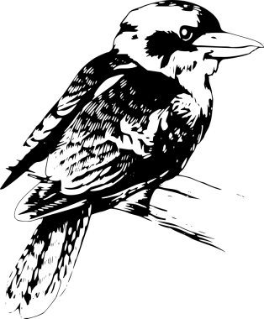

(b) Determine the level of significance for the difference between the mean length of this sample and the known length

**Question 4 [1, 1, 2, 2 & 2 = 8 marks]**

Medication Alpha is designed to help obese individuals lose weight.

For those prescribed this medication, it was found that weight loss was normally distributed with a mean of 18kg and a standard deviation of 4.6kg.

(a) Find the probability that the weight loss was less than 14kg

(b) Find the probability that the weight loss was between 14kg and 21kg

(c) If the weight loss was less than 10kg, Medication Beta was administered instead. If 5000 individuals use the initial medication, how many will need to switch to Medication Beta?

If the physicians require 90% of all individuals to have a weight loss greater than 12kg:

(d) Determine the new mean weight that would correspond to the current standard deviation

(e) If the original mean is maintained, determine the new standard deviation

**Question 5 [1, 2, 1, 2 & 2 = 8 marks]**

An eight-sided die (with faces numbered 1 to 8) is rolled 40 times.

Let $X≡$ the number obtained on one roll

Let $\overline{X}≡$ the mean of 40 numbers rolled

(a) State the probability distribution for X

(b) Calculate the mean and standard deviation for X

(c) State the probability distribution for $\overline{X}$

(d) Find the probability that for any randomly chosen sample of 40 rolls of the die, the mean of the sample is between 2 and 5

(e) Find the probability that in 20 sets of 40 rolls of the die, at least 19 sets would be have sample means between 2 and 5

**Question 6 [1, 2, 2, 2 & 2 = 9 marks]**

The weights of rainbow trout in Lake Rotorua on New Zealand’s North Island are normally distributed with a mean of 2.2kg and a standard deviation of 0.35kg.

(a) What is the likelihood of catching a rainbow trout weighing in excess of 3.0kg?

(b) If a rainbow trout is selected at random, what is the chance it weighs less than 1.8kg, given it weighs less than 2.3kg?

(c) If 20% of the rainbow trout in the lake are underweight, determine the actual weight of an underweight rainbow trout

(d) Determine the probability that the mean of 25 rainbow trout caught in Lake Rotorua lies between 1.9kg and 2.1kg

(e) What size sample is required if we wish to be 98% confident the sample mean will not differ from the true mean by more than 200g?

